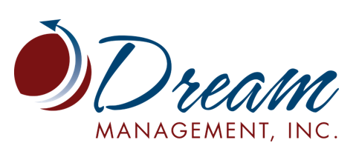
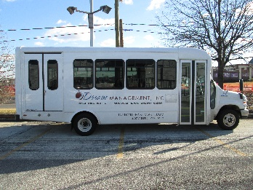
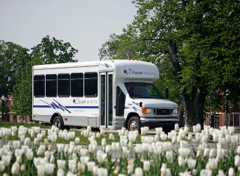

Transportation Services
Capabilities Statement
Dream Management Inc. is a transportation company with 21 years of industry experience. We operate in the Maryland, Virginia and D.C areas and have established a reputation for excellent performance with both the U.S Government and private enterprises alike. We provide our clients with safe, responsive, high quality and prompt performance at an affordable cost.
History
- Established in 1999
- Minority Owned Small Business
- Headquartered in Baltimore, Maryland
Our Services
- Shuttle Services
- Wheelchair equipped Vehicles Service
- Passenger Vans and Buses
- Sedan Vehicle Service
- Passenger Motor Coaches (Charter)
Partial Client List
- Maryland Transit Administration
- US Department of Energy
- Montgomery County Public Schools
- The US Department of Housing and Urban Development (HUD)
- National Guard Bureau
- Nuclear Regulatory Commission
- BWI Partnership
Certifications
- ISO 9001:2015 Certified company
- Maryland Department of Transportation MBE
- US Small Business Administration SDB
- Virginia Department of Transportation DBE

NAICS Codes
- 485991 Special Needs Transportation
- 485999 All other Transit and Ground Passenger Transportation

Past & Current Experience
- Maryland Transit Administration: Dream Management Inc. provides Mobilty/ Para-transit services to elderly, disabled and state employees, to and from work, medical appointments and other travel destinations. At our peak we operated 42 vehicles to provide this service.
- National Guard Bureau: Currently provide 8 shuttle buses operating in a synchronized schedule to meet the militaries demand. We also provide motor coach transportation for the bureau’s special events.
- U.S Department of Energy (DOE): We provide Shuttle transportation services for DOE employees, traveling from agency headquarters to different working locations. Our company provides a scheduled, dedicated, daily operation involving 3- cutaway buses shuttling employees from 7am-7pm Monday-Friday.
- BWI Partnership’s County Connector Shuttle: Provide shuttle service throughout the BWI Airport, Live! Casino & Hotel and Arundel Mills Mall area 7 days a week, 365 days a year.
- Montgomery County Public School District: Currently provide Motor Coach and Minibus transportation for school trips, competitions, games and other events as requested throughout the school year.
Contact Information
- Address: 210 W. 28th Street, Baltimore MD 21211
- Phone: 443-552-5512
- Fax: 443-957-1817
- Email: info@dream-mgmt.com
Luis Gutierrez, President
443-552-5513 (office)
443-677-9159 (cell)
lgutierrez@dream-mgmt.com

